EASTERN INTERNATIONAL UNIVERSITY Practice Assignment – Quarter 1, 2024-2025
SCHOOL OF COMPUTING Course Name: Database
AND INFORMATION TECHNOLOGY Course Code: CSE 301
Student’s Full Name: Nguyễn Khắc Duy
Practice Assignment 4
Student ID: 2131220021
Instruction:
* Students are allowing to write their answers (like SQL queries, Screen shot of outputs, etc.) in word file (Answer sheet) provided by instructor. After finishing the assignment, students must convert the word file (Answer sheet) into a PDF file. Finally, students upload the file in Moodle.
- Use salemanagement database and do following tasks:
  - Add, delete, update value for the columns in table related to calculate new values and constraint.
Note: executing the UPDATE command: In MySQL Workbench if announcement is 1175 error.
- Go to Edit --> Preferences
- Click "SQL Editor" tab and uncheck "Safe Updates" check box
- Query --> Reconnect to Server // logout and then login
- Now execute your SQL query

Or SET SQL_SAFE_UPDATES = 0;
    - How to check constraint in a table?
Example:
SELECT CONSTRAINT_NAME, CONSTRAINT_TYPE
FROM INFORMATION_SCHEMA.TABLE_CONSTRAINTS
WHERE TABLE_NAME = 'salesman';
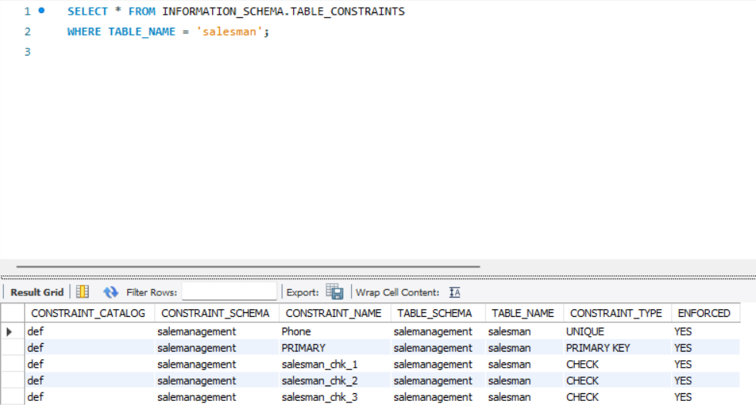
    - Create a separate table name as “ProductCost” from “Product” table, which contains the information about product name and its buying price.

    - Compute the profit percentage for all products. Note: profit = (sell-cost)/cost*100
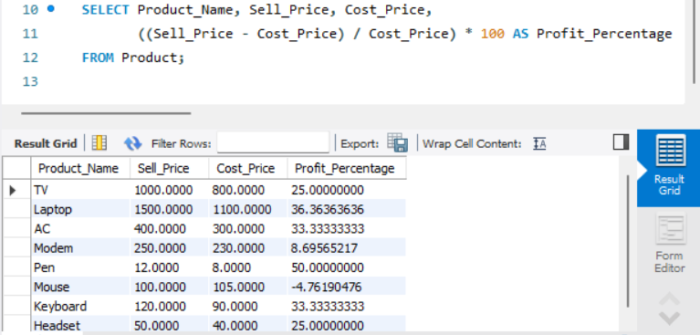
    - If a salesman exceeded his sales target by more than equal to 75%, his remarks should be ‘Good’.
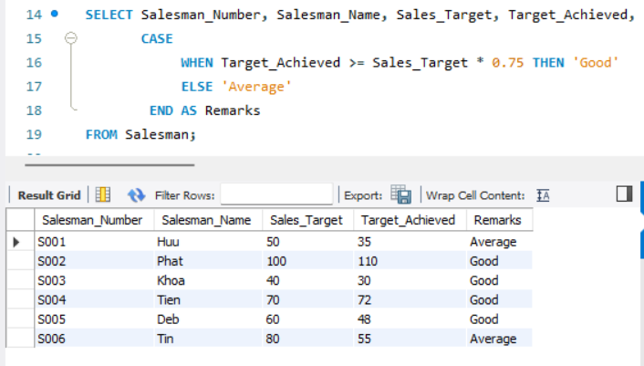

    - If a salesman does not reach more than 75% of his sales objective, he is labeled as 'Average'.
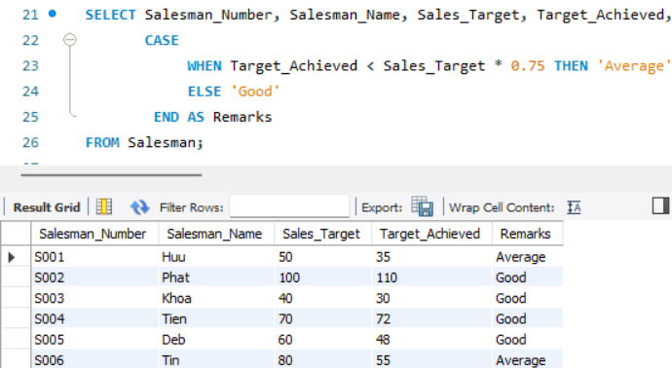
    - If a salesman does not meet more than half of his sales objective, he is considered 'Poor'.
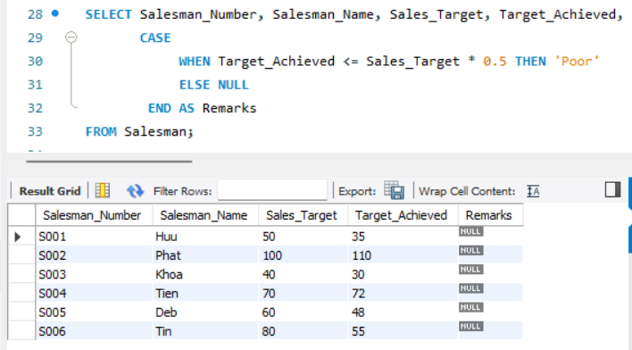
    - Find the total quantity for each product. (Query)
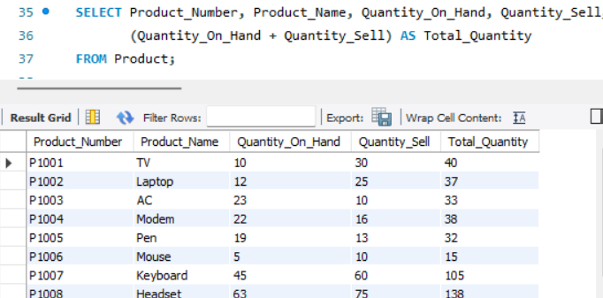
    - Add a new column and find the total quantity for each product.
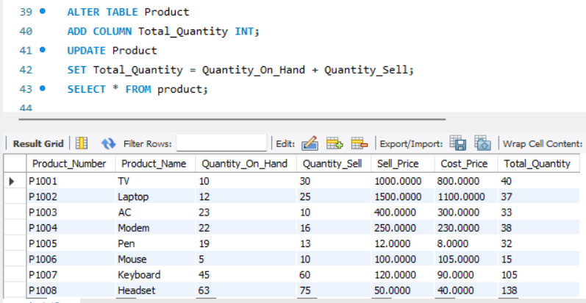
    - If the Quantity on hand for each product is more than 10, change the discount rate to 10 otherwise set to 5.
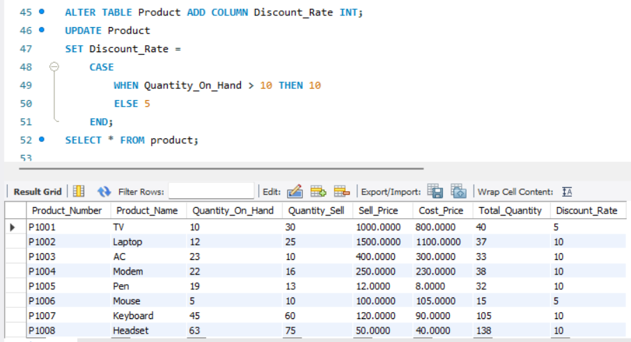
    - If the Quantity on hand for each product is more than equal to 20, change the discount rate to 10, if it is between 10 and 20 then change to 5, if it is more than 5 then change to 3 otherwise set to 0.
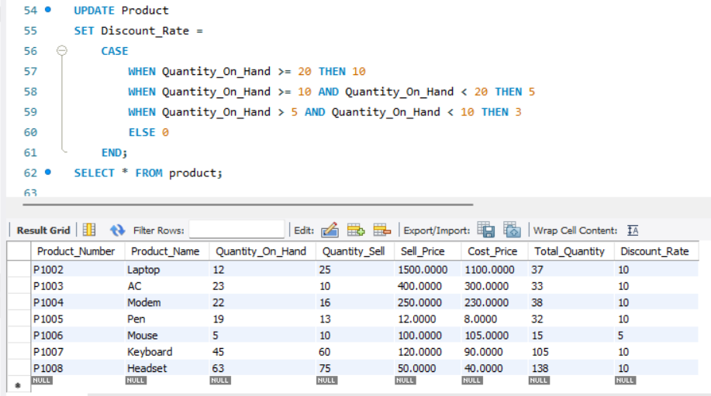
    - The first number of pin code in the client table should start with 7.

- Additional assignments about Constraint
    - Amount paid and amounted due should not be negative when you are inserting the data.
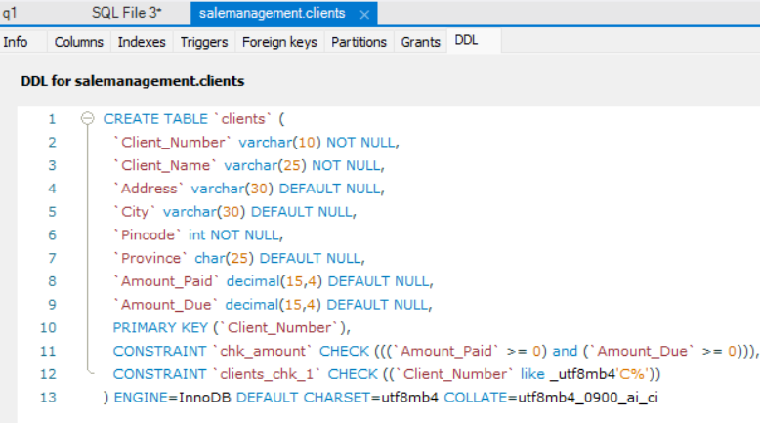
    - Do not enforce the check constraint for pincode.
    - How to alter a check constraint enforcement state?
In MySQL, user cannot alter the enforcement state of a check constraint
    - Remove the constraint from pincode;
    - The sell price and cost price should be unique.
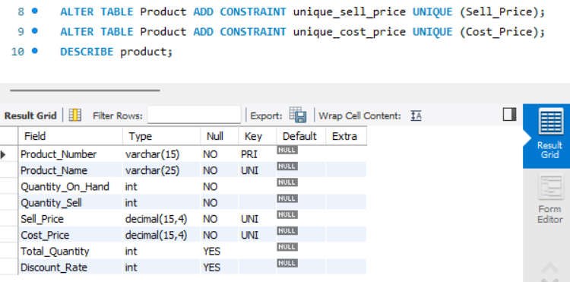
    - The sell price and cost price should not be unique.
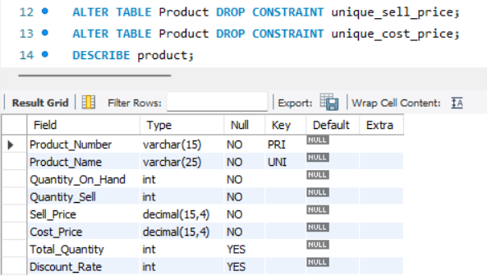

    - Update the delivery status to “Delivered” for the product number P1007.
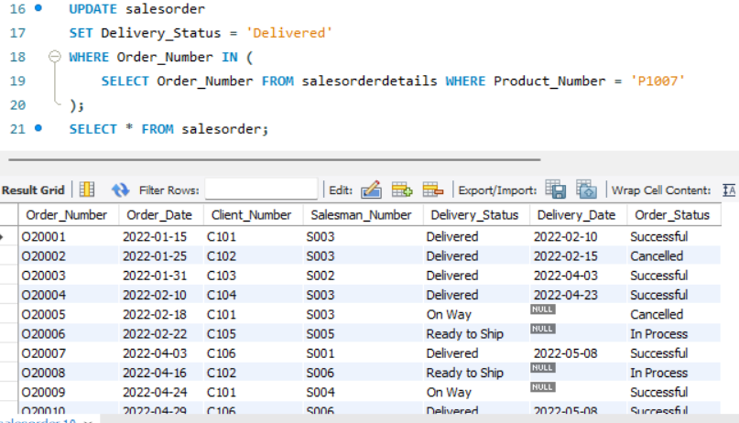
    - Change address and city to ‘Phu Hoa’ and ‘Thu Dau Mot’ where client number is C104.
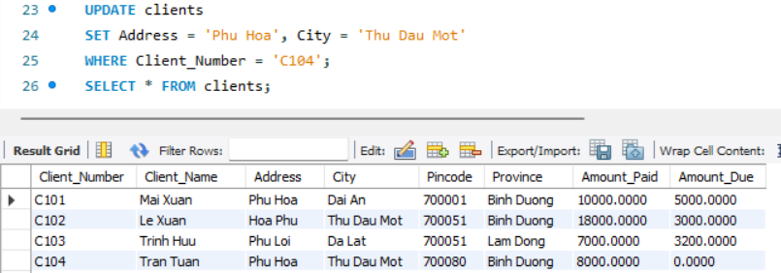
    - Add a new column to “Product” table named as “Exp_Date”, data type is Date.
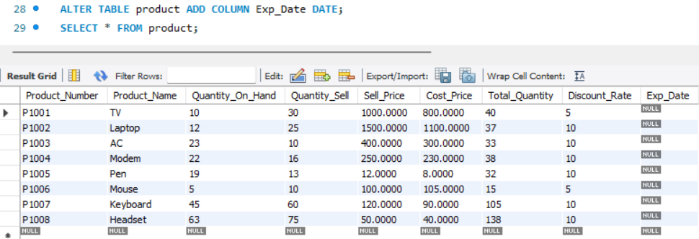
    - Add a new column to “Clients” table named as “Phone”, data type is varchar and size is 15.
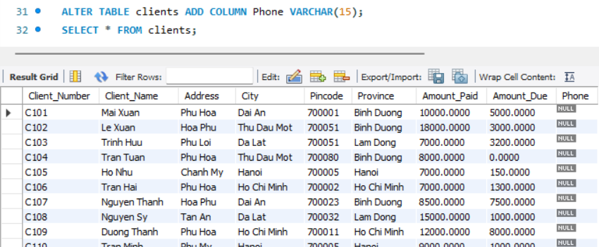
    - Update remarks as “Good” for all salesman.
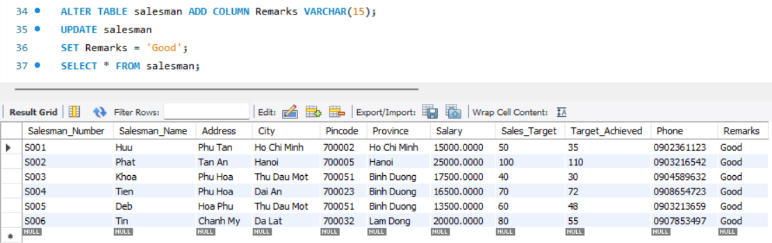
    - Change remarks to "bad" whose salesman number is "S004".
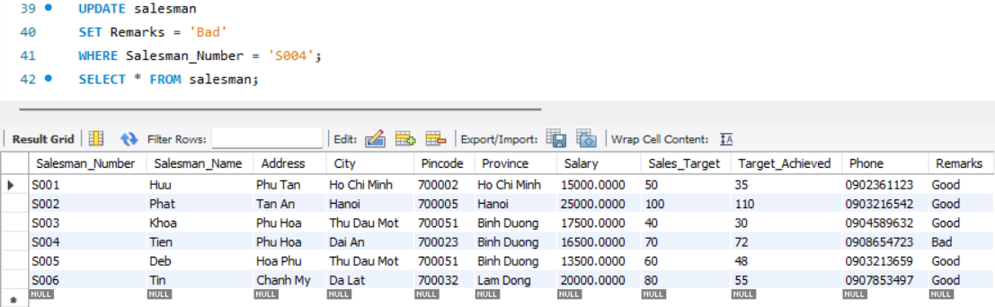
    - Modify the data type of “Phone” in “Clients” table with varchar from size 15 to size is 10.
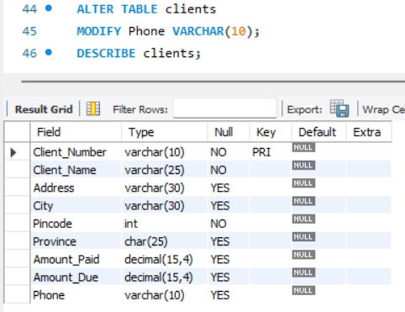
    - Delete the “Phone” column from “Clients” table.
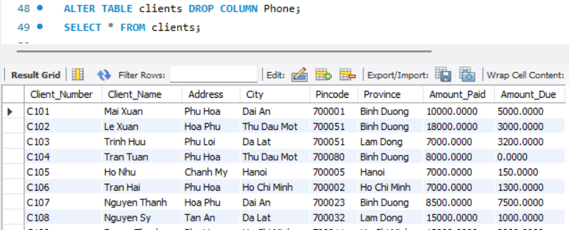
    - alter table Clients drop column Phone;
    - Change the sell price of Mouse to 120.
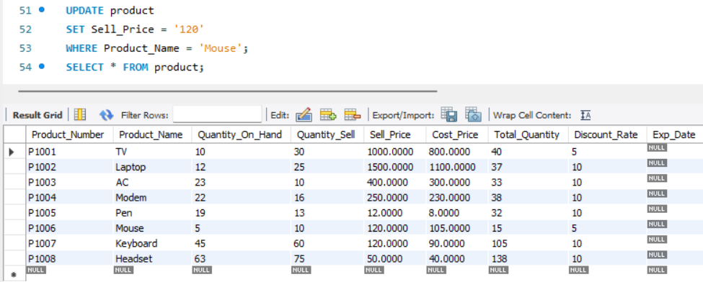
    - Change the city of client number C104 to “Ben Cat”.
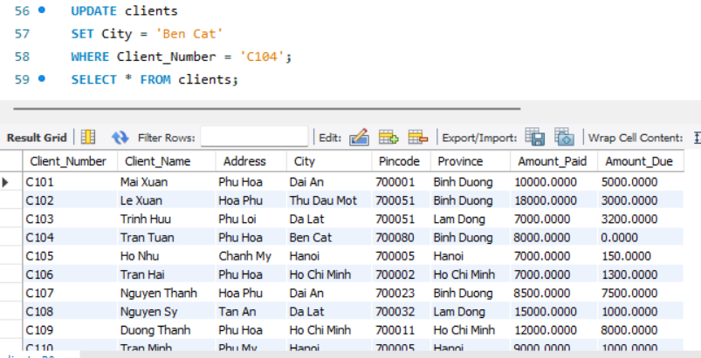
    - If Order_Quantity greater than 5, then 10% discount. If Order_Quantity greater than 10, then 15% discount. Othrwise, no discount.
